27/7/24 CLASS WORK

1. write a java program animal interface that takes no arguments and return void create dog class that implement animal and override speed method to print "dog in barking”;

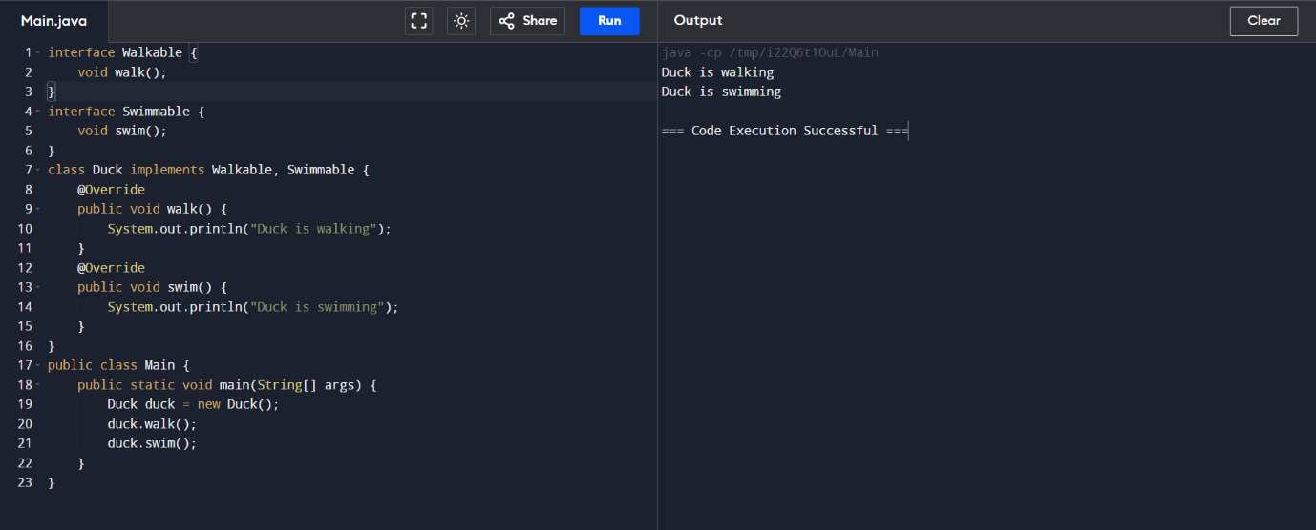

1. create interface walkable wth walk method and create another interface with swimmable with swim method create class duck and implement the interface



1. create a java program to abstract class animal to abstract method sound create subclass lion and tiger that extend the animal class implement the sound method to make a specific sound for each animal

